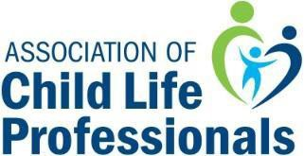
Distinguished Service Award

NOMINATION FORM

Please type your responses into this form, save with the award nominee’s first initial and last name (example: FSmith-DSANomination), and submit it via email to awards@childlife.org.
Please contact awards@childlife.org with any additional questions about the award application. All initial nominations must be submitted by August 7, 2019 in order to be considered.

Name of Nominee:
Place of Employment:
Title:
Agency Address:
City, State Zip
Country
Work Phone: |  | Home Phone:
Email:

Primary Endorser Contact Information:

Endorser Name:
Phone:
Email:

The Distinguished Service Award honors the child life profession’s outstanding leaders and pioneers who have made significant contributions to the field of child life during their careers.
Please attach:
- a brief summary describing what makes the nominee an excellent candidate for the Distinguished Service Award (maximum one page)
- nominee’s current resume/curriculum vitae (if you are not able to secure the resume/CV by August 7, you can attach a brief synopsis of their career and submit the full resume/CV by September 28, 2019)

*All supporting documentation (including endorsement forms and references) is due no later than September 28, 2019.

