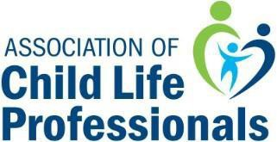
Distinguished Service Award

NOMINATION FORM

The Distinguished Service Award honors the child life profession’s outstanding leaders and pioneers who have made significant contributions to the field of child life during their careers.
Please fill out your nominee’s information and return this initial nomination form, as well as any questions to awards@childlife.org, All initial nominations must be submitted by August 9, 2021 in order to be considered. Please note the eligibility & criteria for a nominee, as well as the nominator’s responsibilities on the ACLP Website.

Name of Nominee:
Place of Employment:
Title:
Agency Address:
City, State Zip
Country
Best Contact #: |  | Member in good standing: yes or no
Email:

Primary Endorser Contact Information:

Endorser Name:
Phone:
Email:

*All supporting documentation (including endorsement forms and references) are due no later than September 09, 2021.

