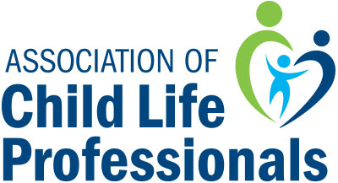

Mary Barkey Clinical Excellence Award 2020 Checklist

Due August 7, 2019
Completed MBA Initial Nomination Form
Submit all documents to awards@childlife.org

Due September 28, 2019
Completed endorsement form with exemplars from two different endorsers.
A letter of support from a current or past employer’s department head or hospital administration
Current resume or CV
Submit all documents to awards@childlife.org

Remember:
*You will need to download or print the nomination and endorsement forms
before completing them.
*Anyone may nominate a qualified ACLP member for the Mary Barkey Clinical Excellence Award.
*The person completing the initial nomination form is considered to be the
person who will gather all nomination package materials and submit them
*For any questions please email awards@childlife.org

