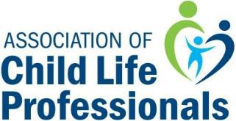
Mary Barkey Clinical Excellence Award

NOMINATION FORM

The ACLP Mary Barkey Clinical Excellence Award is presented to a certified child life specialist who has demonstrated exemplary child life care and a high level of clinical skill.
Please fill out your nominee’s information and return this initial form, as well as any questions to awards@childlife.org. All initial nominations must be submitted by August 9, 2021 in order to be considered. Please note the eligibility & criteria for a nominee, as well as the nominator’s responsibilities on the ACLP Website.

Name of Nominee:
Place of Employment:
Title:
Agency Address:
City, State Zip
Country
Best Contact #: |  | ACLP Member-yes or no:
Email:

Primary Endorser Contact Information:
Endorser Name:
Phone:
Email:

INITIAL NOMINATIONS MUST BE SUBMITTED BY AUGUST 9, 2021
All supporting documentation (including endorsements, exemplars, employer letter of support and a current resume) is due no later September 9, 2021.

